[**The Journal of Undergraduate Research**](http://openprairie.sdstate.edu/jur?utm_source=openprairie.sdstate.edu%2Fjur%2Fvol9%2Fiss1%2F11&amp;utm_medium=PDF&amp;utm_campaign=PDFCoverPages)

[Volume 9 *Journal of Undergraduate Research, Volume*](http://openprairie.sdstate.edu/jur/vol9?utm_source=openprairie.sdstate.edu%2Fjur%2Fvol9%2Fiss1%2F11&amp;utm_medium=PDF&amp;utm_campaign=PDFCoverPages)[*9: 2011*](http://openprairie.sdstate.edu/jur/vol9?utm_source=openprairie.sdstate.edu%2Fjur%2Fvol9%2Fiss1%2F11&amp;utm_medium=PDF&amp;utm_campaign=PDFCoverPages)

## [Article 11](http://openprairie.sdstate.edu/jur/vol9/iss1/11?utm_source=openprairie.sdstate.edu%2Fjur%2Fvol9%2Fiss1%2F11&amp;utm_medium=PDF&amp;utm_campaign=PDFCoverPages)

2011

Parental Influence on Adolescent’s Academic Performance

Jessica Schmuck

*South Dakota State University*

Follow this and additional works at: [http://openprairie.sdstate.edu/jur](http://openprairie.sdstate.edu/jur?utm_source=openprairie.sdstate.edu%2Fjur%2Fvol9%2Fiss1%2F11&amp;utm_medium=PDF&amp;utm_campaign=PDFCoverPages)

Part of the [Educational Psychology Commons](http://network.bepress.com/hgg/discipline/798?utm_source=openprairie.sdstate.edu%2Fjur%2Fvol9%2Fiss1%2F11&amp;utm_medium=PDF&amp;utm_campaign=PDFCoverPages), and the [Secondary Education and Teaching](http://network.bepress.com/hgg/discipline/809?utm_source=openprairie.sdstate.edu%2Fjur%2Fvol9%2Fiss1%2F11&amp;utm_medium=PDF&amp;utm_campaign=PDFCoverPages) [Commons](http://network.bepress.com/hgg/discipline/809?utm_source=openprairie.sdstate.edu%2Fjur%2Fvol9%2Fiss1%2F11&amp;utm_medium=PDF&amp;utm_campaign=PDFCoverPages)

Recommended Citation

Schmuck, Jessica (2011) "Parental Influence on Adolescent’s Academic Performance," *The Journal of Undergraduate Research*: Vol. 9, Article 11.

Available at: [http://openprairie.sdstate.edu/jur/vol9/iss1/11](http://openprairie.sdstate.edu/jur/vol9/iss1/11?utm_source=openprairie.sdstate.edu%2Fjur%2Fvol9%2Fiss1%2F11&amp;utm_medium=PDF&amp;utm_campaign=PDFCoverPages)

ftis Article is brought to you for free and open access by Open PRAIRIE: Open Public Research Access Institutional Repository and Information Exchange. It has been accepted for inclusion in fte Journal of Undergraduate Research by an authorized administrator of Open PRAIRIE: Open Public Research Access Institutional Repository and Information Exchange. For more information, please contact [michael.biondo@sdstate.edu](mailto:michael.biondo@sdstate.edu).

**Parental Influence on Adolescent’s Academic Performance**

### Author: Jessica Schmuck Faculty Supervisor: Soo Hyun Cho, Ph.D. Department: Consumer Affairs

**ABSTRACT**

The purpose of this survey research was to uncover how the relationship of parental involvement and parenting styles influence their adolescent’s academic performance and success. Parents need to be actively involved in their adolescent’s life, support and provide assistance with school and help instill motivation and confidence. This research was conducted by personally distributing surveys to a class of students at the Brookings High School in October 2010. The survey found that half of the participating adolescent’s stated that their parents had a strong influence on their academic performance. This was critical information because it supported previous research conducted regarding the topic. I found that adolescent’s perceptions of their own abilities were strongly linked to their parent’s beliefs about them. Over half of the participants stated that their parents help them work through and cope with stressful situations or school problems. The more involved and supportive a parent is towards their adolescent the higher self-esteem they will gain allowing the adolescent to feel confident and focused during school.

*Keywords*: academic performance, parental involvement, adolescent

# INTRODUCTION

Parental involvement and genuine interest in an adolescent’s school life has a significant influence on their academic performance and ability to focus and efficiently manage homework. Brown & Iyengar (2008) noted that adolescents who lack parental acceptance, behavioral supervision and psychological autonomy start out at a disadvantage by lacking vital skills needed to be academically successful. Adolescents gain and build upon values and academic goals based on those of their parents. When parents are supportive listeners, caring and active in their adolescent’s life then there is less home life stress, allowing the adolescent to have a positive and esteemed attitude towards school. The purpose of this research was to analyze how parental involvement and parenting styles influence adolescent’s academic performance.

# LITERATURE REVIEW

Brown & Iyengar (2008) analyzed all the aspects of parents’ vital roles in adolescent lives. Critical examination of the research done on the influence of parenting styles was evaluated

through the five main aspects, (1) Parental Control; (2) Gender and parenting style; (3) Parental education; (4) perceptual differences between parents and their children; and (5) ethnicity and diversity. Parents’ firm, yet warm and authoritative parenting style proves to be the most successful in creating positive performance and achievements in adolescents.

Parents who create reasonable rules and take active roles in an adolescent’s life will find the student having higher grades and greater performances in school.

Parents should facilitate and encourage independent problem solving, choices and self- determination in their adolescent if parents want them to be independent and motivated in school. Wong (2008) analyzed the effects of parental involvement and autonomy support in relation to academic performance of adolescents. Accurate and informative results were produced from interviewing 171 adolescents with different socioeconomic backgrounds, ethnicities and parental education. The study evaluated the participant’s response to the impact of parental involvement such as, the extent to which parents are interested in, knowledgeable about, and willing to take an active role in the day-to-day activities of their children (Wong, 2008). Proven through multi-group analysis, statistics and results from the participating adolescents, parental involvement had a positive relation with an adolescent’s successful academic performance. Parents who actively participate and are interested in their child’s life will result in them having greater academic performances in school.

Research and studies conducted by other scholars have also proved that the impact of parental roles and involvement positively affect adolescents’ school performance. Spera (2006) analyzed184 adolescents’ perception of parental involvement in school, authoritative parenting styles and parental monitoring at home proving that parental values and interaction positively related to the adolescent’s interest in school, internal academic self-regulation and goal pursuit. According to the same study authoritative parents provided a higher level of emotional security supplying their children with comfort, independence and success in school. Critical analysis of the results confirmed that aspects of parenting are strong predictors of adolescent school achievement and motivation (Spera, 2006). Authoritative parents who engage in bidirectional communication with their children boost the development of interpersonal skills creating positive student adjustment and peer relations, increasing success levels in school both socially and academically. Numerous studies within this research article have been conducted to provide accurate and in-depth analysis on the positive results of parental involvement and authoritative parenting in relation to an adolescent’s success in school.

Cassidy & Conroy (2006) established the idea that parents’ interactions with adolescents shape how they evaluate themselves through self-esteem and achievement levels.

Adolescents’ perceptions of their own abilities are strongly linked to their parent’s beliefs rather than to the adolescent’s actual level of ability. The higher level of parental support and interest in the adolescent the greater amount of self-esteem and confidence the adolescent will feel, thus creating strong, more motivated attitudes towards academics. When an adolescent is confident and content with who they are, it produces self-confidence in school when answering questions and taking exams.

Parents who play an active role in their adolescent’s school attend school activities and help with homework, have proven to increase the adolescent’s academic performance and the amount of time they are willing to put into homework. Spera (2005) analyzed and proved

that parental monitoring, goals, values and aspirations were the basis of where and how their adolescent developed their own. Adolescents who come from parents of a positive, loving, authoritative structure, tend to be more motivated, focused and academically successful.

Parents who provide a rationale for behavior and actions at home are teaching self-control and respect in their adolescent at school towards their teachers and fellow students. When life at home is satisfactory, then life at school becomes much better.

# METHODOLOGY

The research for this paper was conducted on October 26th, 2010 at the Brookings High School. Questionnaire forms were personally distributed to a class of thirty six high school students and thirty six forms were returned by those students who actively participated. The survey included questions of how parental guidance, style and involvement in an adolescent’s life affected the academic performance of the adolescent. In-depth questions about parental interest and guidance towards the adolescent were required to fully comprehend how each parent cared for them and to understand the adolescent’s relation between academics and parents. Questions pursued the adolescents’ opinion on their parents’ ability to help them work through and cope with stressful situations or school problems.

More descriptive questions were asked about the involvement of the parent in the school and what activities they volunteered for to discover the level of participation in their adolescent’s life. A more personal look at the parent to adolescent relationship was questioned through the parent’s ability to provide discipline and explanations to inappropriate adolescent behavior. The questions were presented with multiple choice or yes and no answers as to receive more specific responses of actual adolescents’ perception of their parental experience. Appendix A shows further information on the questions asked from the exact questionnaire form.

# RESULTS

The results were collected from thirty six high school students ranging from the ages fourteen to eighteen years old and surveyed the relationship of their parents.

**Table 1**: Characteristics of the participants.

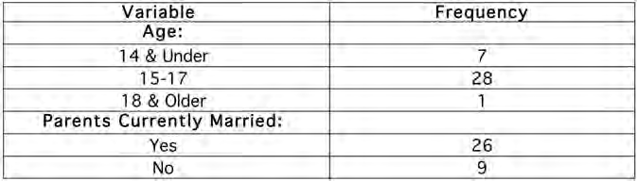

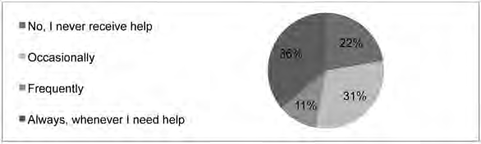

**Figure 1**: Frequency of parental involvement with homework.

Thirteen of the thirty six participants when asked “Do your parents help you with homework?” stated ‘always, whenever I need help.’ Eleven said they ‘occasionally’ receive help and four said they ‘frequently’ get help. A surprisingly high number of eight participants said ‘no, I never receive help.’

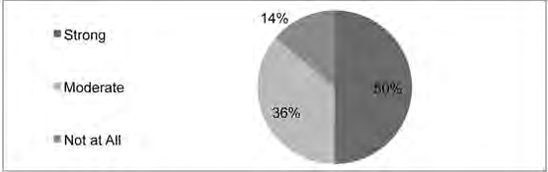

**Figure 2**: Parental influence on adolescent’s academic performance.

The degree at which a parent influences the academic performance of the participants was defined as either strong, moderate or not at all. Eighteen participants said their parent’s had a strong influence on their academic performances. Thirteen said their parent’s had moderate influence on their academic performance and five claimed they had no influence.

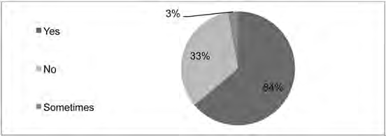

**Figure 3**: Parental guidance through stressful situations and school problems.

Over half of the participants, twenty three, agreed when asked “Do your parents help you work through and cope with stressful situations or school problems?” Twelve participants said ‘no’ they do not receive help and support through stressful situations, leaving one participant with the response that they only receive help ‘sometimes.’

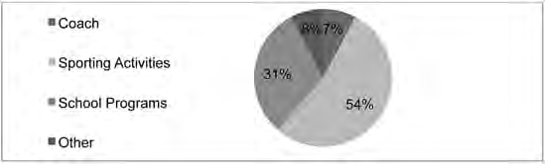

**Figure 4**: Type of parent’s participation in their adolescent’s school activities.

Nine participants said their parents volunteer or take part in their school. The other twenty seven said their parents do not. For the parents who do volunteer or take part in their child’s school participated mostly in ‘sporting activities,’ followed by ‘school programs’. The least amount of results came back for ‘coaching’ and ‘other’.

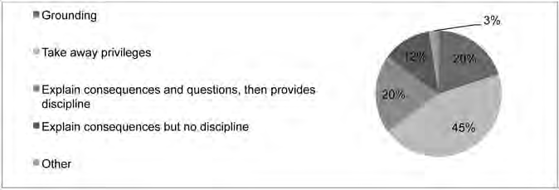

**Figure 5**: Type of parental discipline and explanations for inappropriate behavior.

A total of twenty eight participants stated their parents provide discipline and explanations if their behavior is inappropriate, leaving eight other participants stating their parents provide no discipline or explanations. The most common action taken by parents was ‘taking away privileges’. ‘Grounding’ and ‘explaining consequences and questions, then providing discipline’ was the next response to inappropriate behavior. ‘Explaining consequences’ and ‘other’ brought up the lowest response from parent’s actions.

# CONCLUSION

The results from the high school students supported the research from other scholars in that parents have a significant influence on their adolescent’s academic performance and goal achievement. Half of the participants stated that their parents had a strong influence on their academic performance. The result of this study is consistent with Spera’s (2006) findings confirming how parental values and interaction are positively related to the adolescent’s interest in school, internal academic self-regulation and goal pursuit. Parents are the first people to teach their adolescent values and morals and to prepare them for school and

academic success. The majority of the students agreed that their parents help them work through and cope with stressful situations or school problems. The ability to have their parents supporting them and helping work through issues so they do not feel alone creates a less stressful life which will build a stronger, more motivated student. This is in line with the previous research that adolescents’ perceptions of their own abilities are strongly linked to their parents’ beliefs rather than to the adolescent’s actual level of ability, as found in Cassidy & Conroy’s (2006) critical analysis. The results showed that a small amount of student’s parents volunteered or took part in their school. Research shows that parents who spend a considerable amount of time with their adolescent and play an active role within the school have proven to increase the adolescent’s academic performance in school and the amount of time they are willing to put into homework (Spera, 2005). It is critical that parents increase the amount of time they volunteer or take part in their adolescent’s school.

Strengths within a family need to be recognized to establish a foundation for growth in the family. Otto (1962) was credited with building the foundation for the Family Strengths Framework theory. He identified that commitment to the family, spending enjoyable time together, spiritual well-being, successful management of stress and crisis, positive communication and showing appreciation and affection to family members are all qualities that make a healthy family (Otto, 1962). Healthy families create a positive lifestyle for the adolescents by having little conflict within the family; each member should provide affection, appreciation, encouragement and embrace spiritual well-being. When an adolescent’s home life is satisfactory, their academic performance will be strong and school behaviors will be much more appropriate. The use of positive communication within a family will help the adolescent learn how to communicate with teachers and other students. As shown in Moore & Asay (2008), decision making regarding adolescent educational participation is linked to central family values. Parents have a strong impact on the basic life values and educational plans of their adolescent.

The information developed from surveying South Dakota adolescents provides other scholars and readers with direct adolescent comments on their statement of parental involvement and influence. This offers insight into a stronger view of the research on parents’ influence on their adolescent’s academic performance. However, some limitations on the data gathered from high school students should be noted, including a limited sample size. A broader age category of students and a wider variety of ethnic backgrounds could have increased the generalization of the results. A socially desirable response bias may have occurred during the completion of the survey as well; some individuals may feel uncomfortable telling how they feel about their family or academics causing them to complete the survey with what they think the “appropriate” answer is. Future study on the effect of parental influence on adolescents’ academic performances can benefit by addressing these issues.

# REFERENCES

Brown, L., & Iyengar, S. (2008). Parenting styles: The impact on student achievement. *Marriage & Family Review*, 43(1), 14-38. Retrieved from <http://ejournals.ebsco.com/> direct.asp?ArticleID=4256BB19337AE6259EF6

Cassidy, C., & Conroy, D. (2006). Children's self-esteem related to school- and sport-specific perceptions of self and others. *Journal of Sport Behavior*, 29(1), 3-26. Retrieved from [http://content.ebscohost.com/ContentServer.asp?T=P&](http://content.ebscohost.com/ContentServer.asp?T=P) P=AN& K=19824567& Ebsco Content=dGJyMNHr7ESeqLQ40dvuOLCmr0ieqLFSsqq4Ta6WxWXS& Content Customer=dGJyMPGqskizprJLuePfgeyx%2BEu3q64A& D=keh

Moore, T.J., & Asay, S.M. (2008). *Family resource management*. Thousand Oaks, CA: Sage Publications, Inc.

Otto, H.A. (1962). What is a strong family? *Marriage and Family Living*, 24, 77-81. Spera, C. (2005). A review of the relationship among parenting practices, parenting styles,

and adolescent school achievement. *Educational Psychology Review*, 17(2), 125-146. doi:10.1007/s10648-005-3950-1

Spera, C. (2006). Adolescents' perceptions of parental goals, practices, and styles in relation to their motivation and achievement. *Journal of Early Adolescence*, 26(4), 456-490.

Retrieved from <http://hermes.sdln.net/V/UBY74SGNMGP8C4QGDVCQ2817BYLNK> RJKXLR95LUGD9QPFIC36E-30231?func=meta-3&short-format=002&set_number

=000343&set_entry=000005&format=999

Wong, M. (2008). Perceptions of parental involvement and autonomy support: Their relations with self-regulation, academic performance, substance use and resilience among adolescents. *North American Journal of Psychology*, 10(3), 497-518. Retrieved from [http://web.ebscohost.com.excelsior.sdstate.edu/ehost/detail?vid=9&hid=112&sid=1c4c10](http://web.ebscohost.com.excelsior.sdstate.edu/ehost/detail?vid=9&amp;hid=112&amp;sid=1c4c10) 99-6566-4326-b77b-c16c12ab53fa%40sessionmgr110&bdata=JnNpdGU9ZWhvc3Qtb Gl2ZQ%3d%3d#db=keh&AN=35883346

# APPENDIX A – QUESTIONNAIRE FORM

We are conducting a survey for CA 340-Work Family Interface. These questions are confidential, for research and research only; they will not be shared with anyone outside of this project. These answers are voluntary; you do not have to answer all of them. Do not put your name on this. Please circle all that apply.

Age

1. Are your biological parents currently married? Yes No
2. Do your parents help you with homework?

No, I never receive help Occasionally Frequently Always, whenever I need help

1. At what degree do your parents influence your academic performance? Strongly Moderately Not at all
2. Do your parents help you work through and cope with stressful situations or school problems?

Yes No

1. Do your parents volunteer or take part in your school? Yes No

5-1. If yes, what do they do?

Coach Sporting activities School programs Other

1. Do your parents provide discipline and explanations if your behavior is inappropriate? Yes No

6-1. If yes what actions do they take?

Grounding Take away privileges

Explain consequences and questions, then provides discipline Explain consequences, but no discipline

Other